|  |  |
| --- | --- |
| Overview of Female Population 15 - 49 | |
| Pakistan and Provinces | Population |
| Pakistan | 49,804,461 |
| Punjab | 27,237,594 |
| Sindh | 11,250,052 |
| Balochistan | 2,567,335 |
| KPK | 7,186,092 |

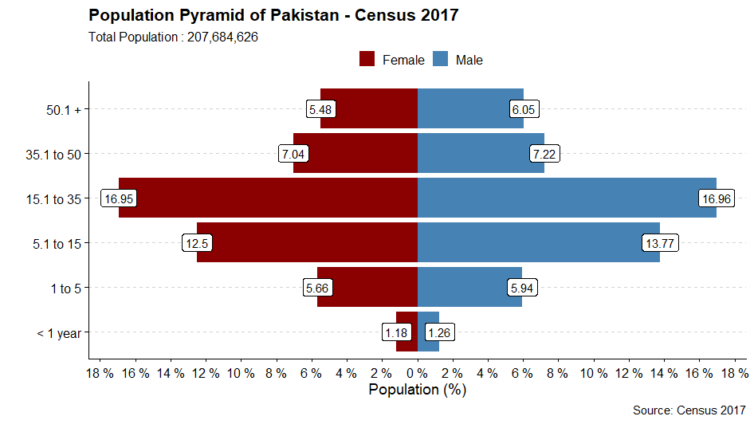

|  |  |  |  |  |  |  |  |
| --- | --- | --- | --- | --- | --- | --- | --- |
| **Pakistan Demographic Overview** | | | | | | | |
| **Age Bracket** | **Male** | **Percent** | **Female** | **Percent** | **Total** | **Percent** |
| < 1 year | 2,614,497 | 2.46% | 2,459,738 | 2.43% | 5,074,235 | 2.44% |
| 1 to 5 | 12,329,627 | 11.60% | 11,759,128 | 11.60% | 24,088,755 | 11.60% |
| 5.1 to 15 | 28,589,596 | 26.89% | 25,963,910 | 25.61% | 54,553,506 | 26.27% |
| 15.1 to 35 | 35,222,062 | 33.13% | 35,193,331 | 34.72% | 70,415,393 | 33.90% |
| 35.1 to 50 | 14,996,364 | 14.11% | 14,611,130 | 14.41% | 29,607,494 | 14.26% |
| 50.1 + | 12,566,074 | 11.82% | 11,379,169 | 11.23% | 23,945,243 | 11.53% |
|  | 106,318,220 | 51.19% | 101,366,406 | 48.81% | 207,684,627 | 100.00% |